

AMERICAN INTERNATIONAL UNIVERSITY–BANGLADESH (AIUB)
Dept. of Computer Science Faculty of Science and Technology

CSC2210: OBJECT ORIENTED PROGRAMMING 2

Summer 2025-2026
Section: [AA] Group No:

Project Report On
Project Name [Agro farm management system]
Supervised By Dr.Md.Iftekharul Mobin
Submitted By:

Name |  |  |  |  |  |  | ID
1. MD.SHAH ALOM |  |  |  |  |  |  | 23-51011-1
2. JANNATUL MAOWA HOSSAIN MEEM |  |  |  |  |  |  | 23-51019-1
3.FAHIM SHAHRIAR SHOMIK |  |  |  |  |  |  | 25-60745-1
4. ISHRAK AHMED SARKER |  |  |  |  |  |  | 23-55642-3
Obtained Marks for CO2 and CO3 (Description given in the following page)
Assessment Criteria | Not Attended/ Incorrect (0) |  | Inadequate (1-2) |  | Average (3) | Good (4) |  | Excellent (5)
Evaluation Criteria (CO2) |  | Total = |  | Evaluation Criteria (CO3) |  |  |  | Total =
Requirement fulfillment |  |  |  | Organization of the application
Validation |  |  |  | Representation and Integration of Database
Verification |  |  |  | Graphical User Interface

CO2: Display and verify the mean of a real-life Project using the concepts of C# Graphical User Interface based environment with database integration to depict a desktop-based application.
Assessment Criteria | Not Attended/ Incorrect (0) | Inadequate (1-2) | Average (3) |  | Good (4) |  | Excellent (5)
Evaluation Criteria | Evaluation Definition
 | Fails to | Demonstrates |  | Presents a basic |  | Effectively |  | Exhibits an
 | demonstrate any | limited |  | depiction of a |  | demonstrates a |  | exceptional
 | understanding of | understanding of |  | real-life scenario- |  | realistic scenario- |  | understanding of
 | real-life scenario- | real-life scenario- |  | based project and |  | based project and |  | real-life scenario-
 | based project | based project |  | identifies some |  | accurately |  | based project
 | development or | development and |  | functional |  | identifies most |  | development and
 | functional | functional |  | requirements. |  | functional |  | accurately
 | requirement | requirement |  | However, the |  | requirements. |  | identifies all
 | identification. | identification. |  | project lacks |  | The project is |  | functional
 | There is no | The project |  | depth or |  | well-developed |  | requirements.
Requirement fulfillment | attempt to depict a project or  identify | depicted lacks coherence or  relevance to real- |  | complexity, and some functional  requirements may |  | with appropriate complexity, and  functional |  | The project is meticulously  developed with
 | functional | life scenarios, |  | be vaguely |  | requirements are |  | thorough
 | requirements | and functional |  | defined or |  | clearly articulated |  | attention to
 | accurately. | requirements are |  | missing key |  | with relevant |  | detail, reflecting
 |  | inaccurately |  | details. |  | details. |  | a comprehensive
 |  | identified or |  |  |  |  |  | understanding of
 |  | insufficiently |  |  |  |  |  | Object-Oriented
 |  | described. |  |  |  |  |  | Programming
 |  |  |  |  |  |  |  | project
 |  |  |  |  |  |  |  | development
 |  |  |  |  |  |  |  | activities.
 | Fails to | Demonstrates |  | Shows a basic |  | Effectively |  | Exhibits an
 | demonstrate any | limited |  | understanding of |  | demonstrates the |  | exceptional
 | understanding or | understanding of |  | validation forms |  | use of validation |  | understanding
 | implementation | validation forms |  | and data |  | forms and |  | and
 | of validation | and data |  | validation |  | implements data |  | implementation
 | forms in their | validation |  | techniques. They |  | validation |  | of validation
 | system. There is | techniques. |  | attempt to |  | techniques. |  | forms and data
 | no attempt to deal | While some |  | implement |  | Validation is |  | validation
 | with data | attempt may be |  | validation, but |  | mostly accurate |  | techniques.
 | validation, and | made to |  | some aspects |  | and |  | Validation is
 | validation | implement |  | may be missing |  | comprehensive, |  | meticulously
Validation | requirements are | validation, it is |  | or incorrectly |  | ensuring the |  | implemented
 | completely | incomplete or |  | implemented, |  | proper handling |  | with thorough
 | ignored or | poorly executed, |  | resulting in |  | of data input and |  | attention to
 | incorrectly | leading to |  | partial or |  | verification in the |  | detail, ensuring
 | applied. | inadequate |  | inconsistent |  | system. |  | robust data
 |  | handling of data |  | handling of data |  |  |  | validation
 |  | validation. |  | validation. |  |  |  | procedures and
 |  |  |  |  |  |  |  | contributing to
 |  |  |  |  |  |  |  | the overall
 |  |  |  |  |  |  |  | reliability and
 |  |  |  |  |  |  |  | integrity of the
 |  |  |  |  |  |  |  | system.
 | Fails to | Demonstrates |  | Shows a basic |  | Identifies and |  | Exhibits an
 | demonstrate any | limited |  | understanding of |  | verifies system |  | exceptional
 | attempt to verify | understanding of |  | verification |  | data, ensuring |  | understanding of
 | the system data | verification |  | processes and |  | proper functional |  | verification
Verification | or functional  requirements. | processes and  data flow in the |  | attempts to verify  system data. |  | requirements are  met. Verification |  | processes and  meticulously
 | There is no | system. |  | However, |  | efforts are mostly |  | verifies system
 | evidence of | Verification |  | verification |  | accurate and |  | data. Verification
 | understanding or | attempts are |  | efforts may be |  | thorough, with |  | efforts are
 | implementation | incomplete or |  | inconsistent or |  | attention to |  | comprehensive

 | of verification | inaccurate, and | lack | ensuring data | and precise, with
 | processes, and | there is | thoroughness, | integrity and | a keen focus on
 | data flow is not | insufficient | and there may be | appropriate data | ensuring all
 | considered. | consideration | gaps in ensuring | flow within the | functional
 |  | given to ensuring | proper functional | system. | requirements are
 |  | data integrity and | requirements and |  | met and
 |  | functionality. | data flow. |  | maintaining
 |  |  |  |  | proper data flow
 |  |  |  |  | throughout the
 |  |  |  |  | system.

CO3: Prepare and Explain a real life desktop based application synthesizing several component of C# along with development tools to adhere the given requirements.
Assessment Criteria | Not Attended/ Incorrect (0) | Inadequate (1-2) | Average (3) |  | Good (4) |  | Excellent (5)
Evaluation Criteria | Evaluation Definition
 | Fails to identify | Limited |  | Lacks depth or |  | Consider and |  | Generalize and
 | any suitable real | understanding |  | relevance to OOP |  | integrate the idea |  | exhibits an
 | time application | about the project |  | project |  | of several core |  | exceptional
 | or requirements | scopes and |  | development |  | aspects of the |  | understanding of
 | for project | scenarios or |  | activities and |  | project along |  | project
 | development | identification of |  | may contain |  | with relevance to |  | preparation
Organization of the application | activities related to OOP. | functional requirements. |  | inaccuracies.  Real-life scenarios are |  | real-life  scenarios. Demonstrating a |  | according to a to  real-life scenarios. Also
 |  |  |  | mentioned, but |  | solid |  | contains proper
 |  |  |  | the discussion |  | understanding of |  | and insightful
 |  |  |  | lacks depth or |  | the application |  | identification of
 |  |  |  | clarity. |  | presentation. |  | the system which
 |  |  |  |  |  |  |  | is comprehensive
 |  |  |  |  |  |  |  | and precise.
 | Fails to identify | Limited |  | Lacks depth or |  | Integrate the |  | Exhibits an
 | and present any | understanding of |  | relevance to |  | database with the |  | exceptional
 | understanding or | the database |  | database |  | forms properly |  | understanding
 | implementation | concepts or their |  | integration with |  | and implements it |  | and
 | of database. Also | proper way of |  | the application. |  | with proper |  | implementation
 | failed to integrate | using in a real |  | Shows a basic |  | validation which |  | of database
 | the data with the | time project. |  | understanding but |  | is mostly |  | ensuring
Representation and | project itself. | While some |  | some aspects |  | accurate and |  | attention to
Integration of Database |  | attempt may be |  | may be missing |  | comprehensive, |  | detail, and robust
 |  | made to |  | or incorrectly |  | ensuring the |  | data manipulation
 |  | implement but it |  | implemented, |  | proper handling |  | procedures and
 |  | is incomplete or |  | resulting in |  | of data input and |  | contributing to
 |  | poorly executed, |  | partial or |  | verification along |  | the overall
 |  | leading to |  | inconsistency. |  | with general |  | clarity.
 |  | inadequate |  | May lack proper |  | normalization.
 |  | design. |  | normalization.
 | Fails to present or | Limited |  | Shows a basic |  | Effectively |  | Exhibits an
 | prepare GUI | understanding of |  | understanding of |  | identifies and |  | exceptional work
 | based application | graphical user |  | creating user |  | meet the consider |  | design following
 | interfaces. There | interfaces. Lack |  | interfaces. Most |  | the simplicity. |  | a high standard of
 | is no evidence of | of design |  | of them are |  | Design related |  | simple and
Graphical User Interface | creating or integrating such  things according | knowledge. Very poor attempt to  make such things |  | interconnected but maybe some  of them lack it. |  | works are mostly accurate and  taken proper |  | elegant work. Several controls  and mechanism
 | to their | which are |  | However, most of |  | attention to |  | has been
 | usefulness. | currently obsolete |  | it can be |  | ensuring a user- |  | organized in a
 |  | or can’t be |  | described as user |  | friendly coherent |  | preferred way
 |  | identified as |  | friendly. |  | system. |  | according to the
 |  | coherent. |  |  |  |  |  | coherent usage .

Table of Contents

- Introduction
- Project Overview and Case Study
- System Functionality
- Database Design and Schema Diagram
- SQL Queries
- UI/UX Design and Navigation
- Colourful Application Screens
- Features and Facilities
- Conclusion

Introduction
AgroBridge is a desktop-based agricultural marketplace and product management application developed using C# Windows Forms with SQL Server database integration. The system connects three main user roles: Admin, Farmer, and Customer. Farmers can manage agricultural products, customers can browse products and maintain a shopping cart, and administrators can supervise registered users and overall system activities.

Project Overview and Case Study
In a typical agricultural marketplace, farmers need a simple way to publish products and manage price and quantity, while customers need a convenient interface to find products and place orders. AgroBridge brings these activities into one role-based desktop application.
  - Farmer workflow: A farmer logs in, adds a product with product name, price, and quantity, and can later view, update, search, or remove only products associated with that farmer account.
  - Customer workflow: A customer logs in, loads the available product list, searches products by name, adds selected products to a personal cart, removes products if necessary, and proceeds toward order processing.
  - Admin workflow: An administrator accesses administrative functions and registered-user management. User status is used to control whether an account is active or inactive.
  - Authentication workflow: The login process verifies Username and Password and then opens the appropriate interface according to the stored role: Admin, Customer, or Farmer.

System Functionality
Functionality | Description
User Registration and Login | Users can register and authenticate with role-based access. The application checks account credentials and active status before opening the correct dashboard.
Role-Based Dashboards | Separate interfaces are provided for Admin, Farmer, and Customer users to keep each  workflow organized.
Farmer Product Management | Farmers can add products, view their own products, search product names, update product information, and remove products. Ownership is checked using FarmerID.
Customer Product Browsing | Customers can load available products from the database and search products by product  name.
Shopping Cart Management | Customers can add products to a cart, prevent duplicate selections, remove individual products, and clear the cart.
Order Management | The project contains customer order functionality and screens for viewing customer orders.
Registered User Management | Administrative functionality includes managing  registered users and account status.
Password Management | The application provides a dedicated change-password interface.

Database Design and Schema Diagram
The project uses the AgroBridgeDB SQL Server database. The application source directly references RegistrationTable and ProductTable. Order-related functionality is also represented by the customer order screens, so the schema below presents the core marketplace data flow used by the application.
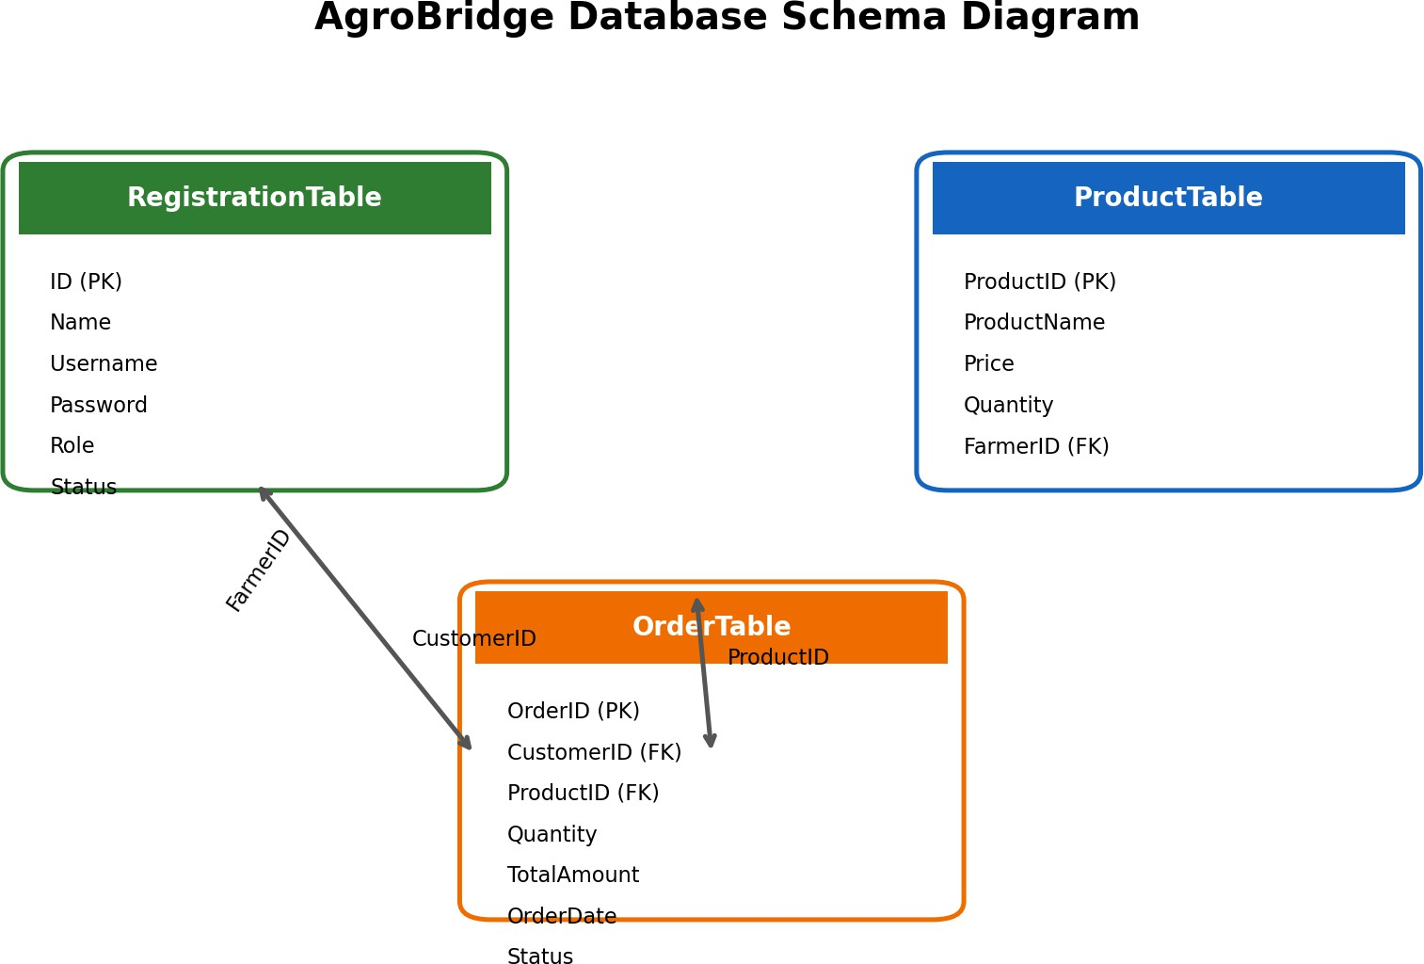

Figure 1: AgroBridge core relational database schema

Core Tables
RegistrationTable: Stores user account information including ID, Name, Username, Password, Role, and Status. Role determines Admin, Customer, or Farmer access.
ProductTable: Stores ProductID, ProductName, Price, Quantity, and FarmerID. FarmerID identifies the farmer who owns a product.
OrderTable: Represents customer order information for the marketplace workflow, linking customers and products with quantity, amount, date, and status.

SQL Queries

Create Database
CREATE DATABASE AgroBridgeDB;
USE AgroBridgeDB;

RegistrationTable
CREATE TABLE RegistrationTable (
ID INT IDENTITY(1,1) PRIMARY KEY, Name VARCHAR(100) NOT NULL,
Username VARCHAR(50) NOT NULL UNIQUE, Password VARCHAR(100) NOT NULL,
Role VARCHAR(20) NOT NULL, Status INT NOT NULL DEFAULT 1
);

ProductTable
CREATE TABLE ProductTable (
ProductID INT IDENTITY(1,1) PRIMARY KEY, ProductName VARCHAR(100) NOT NULL,
Price INT NOT NULL,
Quantity INT NOT NULL, FarmerID INT NOT NULL,
FOREIGN KEY (FarmerID) REFERENCES RegistrationTable(ID)
);

Add Product
INSERT INTO ProductTable (ProductName, Price, Quantity, FarmerID) VALUES (@pname, @price, @qty, @farmerID);

View Farmer Products
SELECT ProductID, ProductName, Price, Quantity FROM ProductTable
WHERE FarmerID = @farmerID;

Search Products
SELECT ProductID, ProductName, Price, Quantity, FarmerID FROM ProductTable
WHERE ProductName LIKE '%' + @search + '%';

Update Product
UPDATE ProductTable
SET ProductName=@pname, Price=@price, Quantity=@qty WHERE ProductID=@pid AND FarmerID=@farmerID;

Remove Product
DELETE FROM ProductTable
WHERE ProductID=@pid AND FarmerID=@farmerID;

UI/UX Design and Navigation
AgroBridge uses a role-oriented UI/UX structure. The main objective is to minimize unnecessary screens for each user and provide direct navigation to the tasks relevant to that role.
  - Welcome Screen → Login / Registration
  - Login → Admin Dashboard → Registered User Management
  - Login → Farmer Dashboard → Add Product / View Products / Update Product / Remove Product
  - Login → Customer Dashboard → Browse Products → Add to Cart → Cart → Orders
  - Any authenticated user → Change Password
The interfaces use clear labels, input fields, action buttons, data grids, and dashboard navigation. The following colourful screens are visual UI representations based on the application's available forms and workflows.

Colourful Application Screens

Login Screen

Figure 2: Login interface with username and password authentication.

Customer Dashboard and Product Catalogue
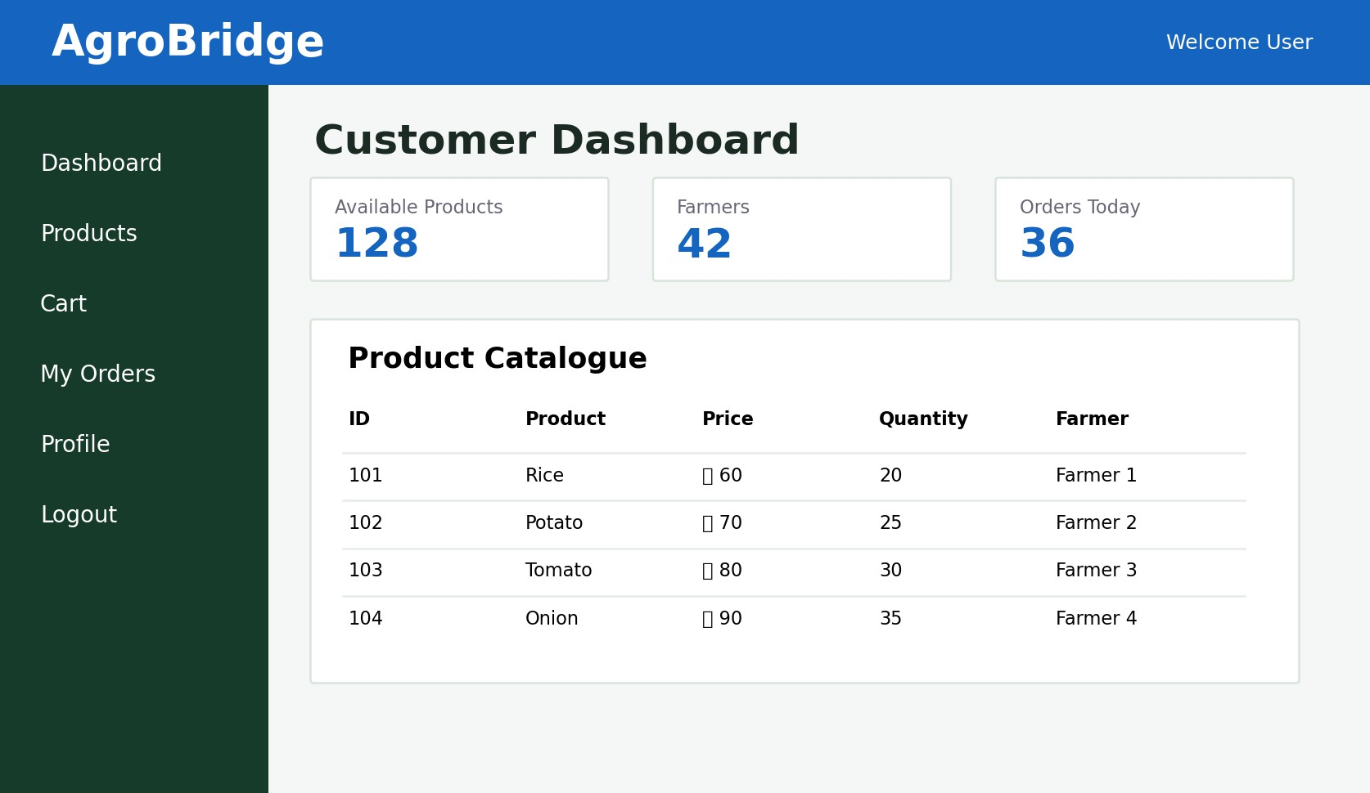
Figure 3: Customer product browsing interface and marketplace overview.

Farmer Product Management
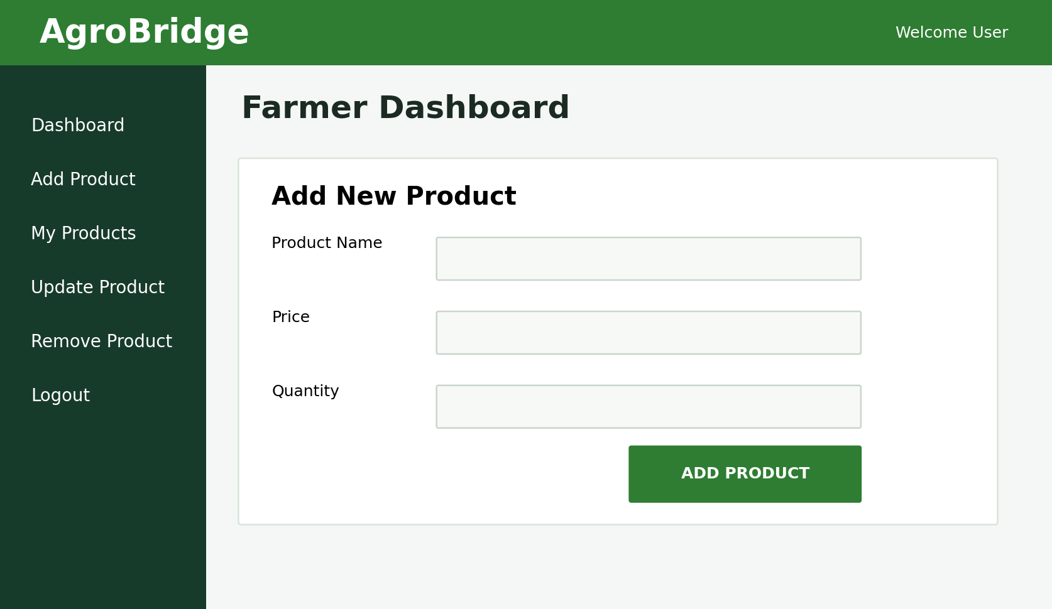
Figure 4: Farmer interface for adding and managing agricultural products.

Customer Cart and Checkout
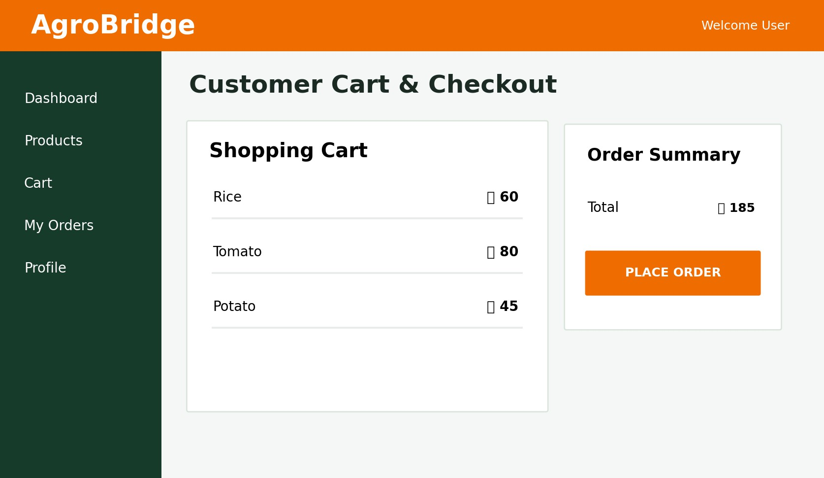
Figure 5: Shopping cart and order summary interface.

Features and Facilities
  - Role-based authentication for Admin, Customer, and Farmer users.
  - Account status checking to prevent inactive users from accessing the system.
  - Farmer-specific product ownership and product management.
  - Product addition, viewing, searching, updating, and removal.
  - Customer product browsing and search capability.
  - Shopping cart with duplicate-product prevention.
  - Cart item removal and clear-cart functionality.
  - Customer order and profile interfaces.
  - Administrative registered-user management.
  - Password change functionality.
  - C# Windows Forms graphical interface with SQL Server integration.

Conclusion
AgroBridge demonstrates a practical object-oriented desktop application for an agricultural marketplace. By separating the workflows of administrators, farmers, and customers, the system provides an organized way to manage user accounts, agricultural products, customer selection, and order-related activities. The integration of C# Windows Forms and SQL Server supports persistent data management, while the role-based UI improves usability. The project can be extended in the future with online payment, product categories, delivery tracking, sales reports, and stronger password security.

